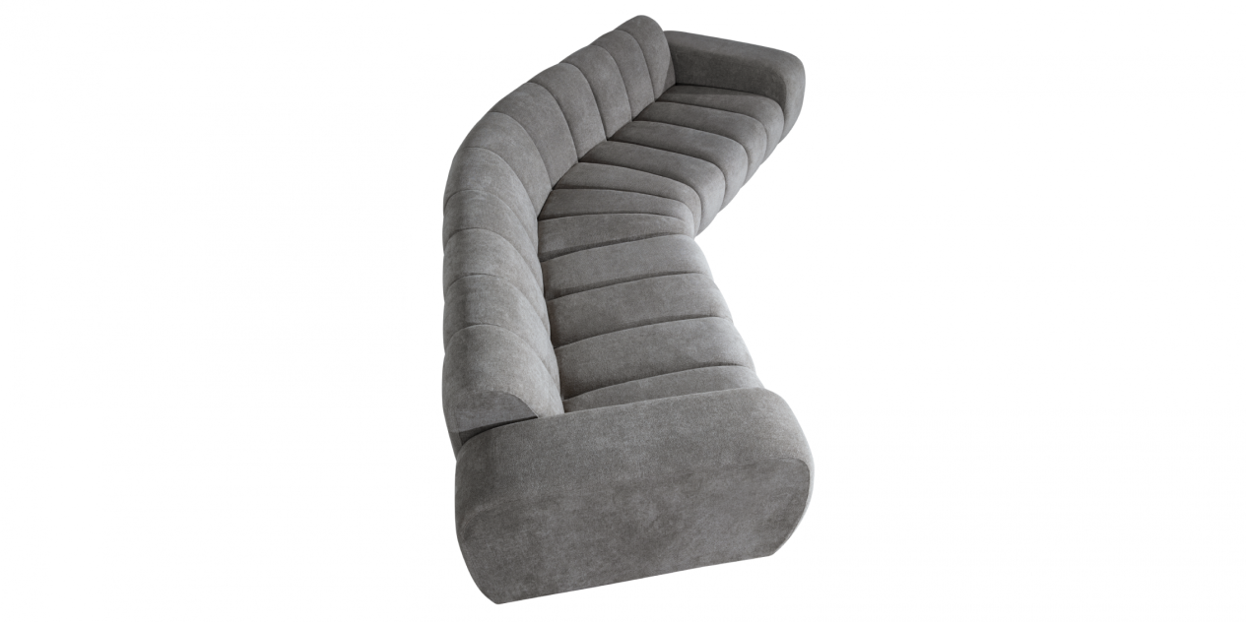

$1.418,90

Creating a chic yet elegant living space with solid form and soft curves meld in this Wave sofa. Thanks to its modular elements that can be expanded to suit every individual taste, you have no worries about a small or large room, especially when this couch is your corner space saver. The sofa is available in a wide range of colors and fabrics. You can't stop the Wave from coming, but you can sit on it

